Med BSO Academy - BOOST Your MED Initiative!
Euro-Mediterranean Cooperation Summer School
Cagliari, November 8th & 9th 2018 – Hotel Regina Mergherita

Logistic Note

Place & date of the meeting

The Euro-Mediterranean Cooperation Winter School will take place at Hotel Regina Margherita, Viale Regina Margherita 44, Cagliari, Sardinia, Italy on November 8th and 9th, 2018.
Meals

The organizers are glad to offer to participants a light lunch on November 8th and 9th.

How to get there

The nearest airport is Cagliari Elmas, 8 km away (15 minutes by car) from the city centre.

DIRECTIONS FROM CAGLIARI AIRPORT TO MATTEOTTI STATION, CAGLIARI

By public transport: the train station at the airport is just 5 minutes’ walk from the air terminal. The rail service starts at about 5AM and ends after 9PM with 20 mins. average frequency. The journey to and from Cagliari takes 5-7 mins, a single fare is 1.30 euro. Tickets are sold by Trenitalia at the vending machines (located in Arrivals and at the train station), online, and by authorized dealers. For the train timetable please check out Cagliari airport website.

By taxi: A standard journey during daytime costs approximately between 15 and 20 euros.

DIRECTIONS FROM MATTEOTTI STATION TO VIALE REGINA MARGHERITA 44, CAGLIARI

By foot: Hotel Regina Margherita can be reached within a 12 minutes’ walk.

Accommodation

Hotel Flora ****

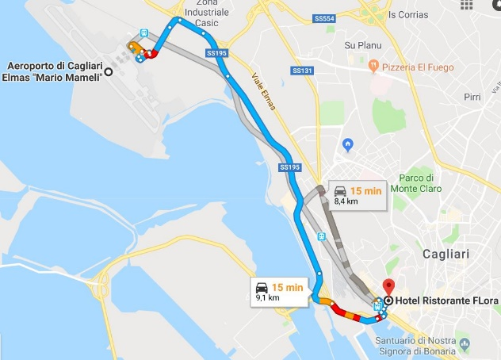
Via Sassari, 45, 09124 Cagliari, Italy
Tel: +39.070.658219
E-mail: info@hotelfloracagliari.it

Classic room: 115€/night

It is a special fare reserved to Med BSO Academy participants. It is necessary to attach the booking form according to the on-line application form on www.euromedsummerschool.eu

Airport vs Hotel Flora

Hotel Regina Margherita ****

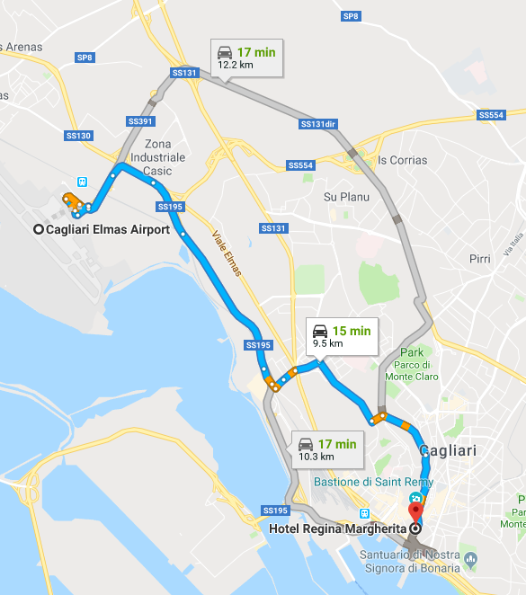
Viale Regina Margherita 44, 09124 Cagliari, Italy
Tel: +39 070 670342
E-mail: booking@hotelreginamargherita.com
Classic room: 125€/night

It is a special fare reserved to Med BSO Academy participants. It is necessary to attach the booking form according to the on-line application form on www.euromedsummerschool.eu

Airport vs Hotel Regina Margherita

